1. **Command**:
   1. **logstash -e “input { stdin {} } output { stdout{} }”**
      1. **logstash**: binary.
      2. **-e**: To send pipeline configuration directly from the command line to the Logstash library.
      3. input{}: To define source of input like STDIN, HTTP, File etc.
      4. stdin{}: input plugin.
      5. 
2. **Defining pipeline configuration in a file**.  
   A screenshot of a computer

   Description automatically generated  
   **Command**: logstash -f pipeline.conf
3. **Codec : To decode the output.  
   Ruby Debug Codec to print the output in JSON Format.**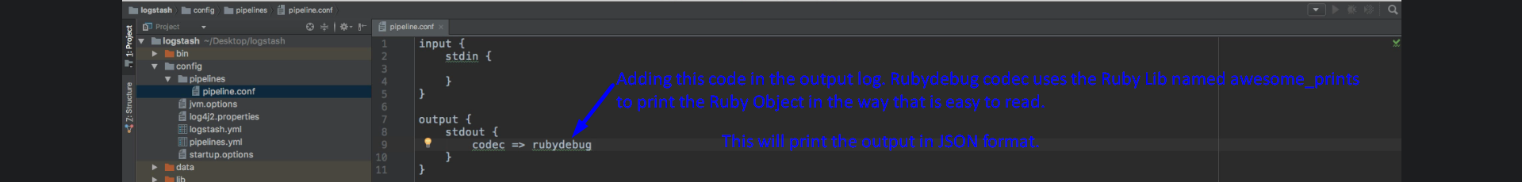  
   **Input and Processed Event in JSON.**  
   A screen shot of a computer

   Description automatically generated with low confidence